JJ Abides and Peter Stanton

March 11, 2018

CSS 490

Professor Dimpsey

# Program 5: Final Project – Documentation

## **URL**

<http://spotifysearchengine.azurewebsites.net/>

## **What is our Cloud Service?**

Our cloud service is a web app called The Spotify Search Engine, which takes a search input for a song artist, utilizes Spotify’s API to get a list of artists with the given name, and can store an artist’s album and song data into an Azure Table for querying. Information about a song artist’s next live performances are also given through the utilization of Ticket Master API.

## **Services Utilized**

* Azure Web Apps – For running our website
* Blob Storage – For storing all searches to form a statistic on popular searches
* Azure Table Storage – For storing the data about an artist and making queries
* Git Hub – For version control
* Azure Application Insights – For monitoring app usage and sending alerts
* Spotify API – For utilizing Spotify’s login and obtaining song artist data
* Ticket Master API – For obtaining information on an artist’s next live performance (if any)

## **Design Diagram**

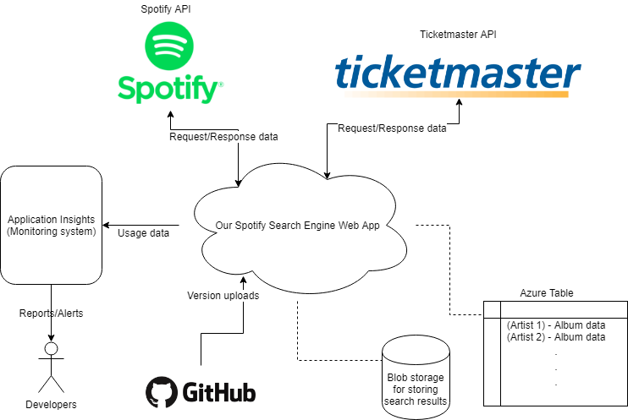

## **Why did we choose Azure?**

We used Azure to build our program 4 web app and we’re basing our Spotify Search Engine web app based on what we learned from program 4. So, we chose Azure because we are most familiar with it for web app development.

## **Monitoring the System for Availability**

We monitor the web app through the Azure dash board and the Application Insights service. Application Insights provides us with a complete overview of metrics such as performance, failures, usage, and availability. We use Application Insight’s Smart Detection feature to email me (JJ) and Peter in case of any issues.

## **Service-Level Agreement (SLA)**

Because we are using the free tier service to run our web app, we are not guaranteed an availability percentage.

As stated by Microsoft Azure’s SLA for App Services:

We guarantee that Web Apps running in a customer subscription will be available 99.95% of the time. No SLA is provided for Mobile Apps, Logic Apps, or API Apps while such services are still in Preview or for Apps under either the Free or Shared tiers.

If we can assume that we will at least have 99.95% availability for running our web app using Azure Web Apps, then we could multiply that availability with the availability of all the other services we are using (that are required to run the app) to get an availability percentage for the whole web app.

* Blob storage availability: 99.99%
* Table Storage availability: 99.99%

Thus, the potential availability of our app is 99.93%.

## **How Our App Will Scale with Load**

Because we are using the free tier service, our web app will not auto scale. If we were to scale it, however, we would shift our tier service to B1 Basic to improve processing, availability, and storage size. Auto scaling would also be enabled for scaling out.